**Exploring the Dynamics of Grievance Redressal Systems: A Comprehensive Review**

Pallavi Sharmaa, Yuvraj Narayan Mishrab, Vishal Yadavc , Shruti Gautamd

aKIET Group of Institutions, Delhi-NCR Meerut Road, Ghaziabad, 201206, India

bKIET Group of Institutions, Delhi-NCR Meerut Road, Ghaziabad, 201206, India

cKIET Group of Institutions, Delhi-NCR Meerut Road, Ghaziabad, 201206, India

dKIET Group of Institutions, Delhi-NCR Meerut Road, Ghaziabad, 201206, India

**Abstract:** One of the main goals of the initiative is to identify and resolve public complaints as quickly as possible. In order to accomplish this goal, people are provided with the chance to voice complaints regarding different matters concerning their local communities. These problems cover a wide range of topics, including delicate considerations pertaining to law and order, sociological difficulties including child labour and harassment of women, and problems with garbage management, water supply, energy, transportation, and sewage. Administrative organisations face a big difficulty when it comes to handling citizen complaints, which calls for effective categorization and prioritisation of these issues. The creation of a web application to methodically analyse numerous complaints in order to pinpoint common problems is suggested in this study.

**Keywords:** Grievance Redressal System, Grievances, Redressal, Transparency, Complaint management, Citizen engagement, Timely resolution, Accountability, Citizen empowerment, User satisfaction, Continuous improvement, User feedback, Problem classification, Administrative responsiveness.

1. INTRODUCTION

In today's civilizations, complaints are an unavoidable part of social interactions because of differences, injustices, and internal conflicts. Upholding fairness and equity as well as social cohesiveness and institutional trust depend on these complaints being resolved effectively. As a result, governments, organisations, and communities all around the world now need to build strong grievance redressal mechanisms.

The purpose of this research article is to investigate the complexities of grievance redressal systems, looking at their importance, difficulties, and changing paradigms. Our specific goals are to: Recognise how HTML, CSS, Javascript, and PHP contribute to the Grievance Redressal System's functionality and how grievances are addressed and promptly resolved. Encourage accountability and openness in grievance redressal processes by putting forth measures that make the grievance resolution process more transparent, guarantee that complainants are treated fairly, and hold responsible parties accountable for their deeds or inactions.

1. LITERATURE SURVEY

[1] This research aims to develop a unified model for e-government adoption in India, validated using data from 419 citizens and nine other models. The proposed model outperforms others, explaining 66% variance in behavioral intentions and showing significant relationships. The study also presents limitations and implications for theory and practice. [2] This paper investigates the factors influencing the adoption of the online public grievance redressal system (OPGRS) in India, based on the government's strategic policy to reform bureaucracy. The model, based on UTAUT, includes constructs like performance expectancy, effort expectancy, social influence, facilitating conditions, self-efficacy, and behavioral intention. The study aims to improve OPGRS's potential for transparency and corruption-free India.

[3] India's states provide online services to empower citizens, addressing issues like corruption and bureaucracy. The Department of Administrative Reforms and Public Grievances (DARPG) addresses grievances from various departments. This paper considers four Indian states and their grievance redressing systems, measuring their performance on a scale. Key metrics include HarSamadhan of Haryana, eSamadhan of Himachal Pradesh, SWAGAT of Gujarat, and JanMitra of Karnataka. [4] This paper examines the success of India's online public grievance redressal system (OPGRS) using an IS success model. It measures intention to use and user satisfaction, finding positive connections between system quality, information quality, perceived usefulness, user satisfaction, and intention to use. [5] The Grievance Redress System (GRS) is a crucial tool for Bangladesh's public administration. Introduced in 2007, it has evolved into an online system in 2014 to address citizens' grievances. A study assessed the implementation of GRS in district-level government offices, revealing that it is still in its infancy. Service providers were found to be insufficiently following GRS guidelines, with stumbling blocks including complaints submission, institutional incapacity, and lack of monitoring. The study concluded that institutionalizing awareness building programs, service provider capacity development, establishing a separate legal authority, and result-based monitoring are essential for better GRS outcomes.

[6] Bitcoin's popularity has led to the development of blockchain, which has been applied across various domains, including the grievance redressal system. This system involves submitting grievances to different hierarchical levels of authority, each with the authority to resolve, revert, and forward them to higher levels. Data integrity is built-in, preventing misuse of power by authorities. The dynamic time threshold transfers grievances to higher authorities, eliminating ignorance and overcoming anomalies in the current grievance system. [7] Griefs in academic institutions are sensitive and important, especially for students who often fail to express their concerns. Despite a lack of a formulated grievance redressal mechanism in some prestigious colleges of Madhya Pradesh, a prototype has been developed to address these conflicts. This paper focuses on developing and executing this prototype, addressing the identified problem areas and incorporating additional necessary areas to ensure effective grievance redressal for students.

[8] The Grievance Redressal Mechanism (GRM) is crucial in a fast-paced world, especially during the pandemic. It facilitates smooth functioning by receiving complaints and redressing them effectively. With growing technologies and digital literacy, GRMs have become more accessible, user-friendly, and contactless. This paper reviews existing literature and looks at recent on-field examples of e-governance innovations in states like Kerala, Himachal Pradesh, and Bihar. However, challenges include the ability of GRMs to be accessible to the general public and bridging the digital divide. The paper seeks solutions to these problems for a better future for all.

[9] Grievances arise at any level, especially in education, where students often fail to seek support. A Student Grievance Support System was designed to address these issues. The web application allows students to lodge complaints, which are forwarded to the Grievance Redressal Committee. The committee then forwards the complaints to the appropriate institute or department, ensuring sensitivity. The institute or department takes action and updates the status, providing transparency and enabling students to find solutions. This project aims to improve student experience and satisfaction. [10] This paper examines the success factors of online public grievance redressal systems (OPGRSs) in India, focusing on system quality, information quality, social influence, self-efficacy, perceived trust, user satisfaction, and intention to use. The study aims to improve OPGRS's potential for a transparent, corruption-free country.

[11] In India, citizens expect quality public services, including information technology-enabled versions. To increase citizen satisfaction, countries worldwide aim to develop transparent and accountable online systems. This study aimed to assess the e-service quality of an online grievance redress portal for student users. A survey of 677 respondents was conducted using partial least squares structural equation modeling. Results showed that security and privacy are crucial for student satisfaction, as they build trust in the online e-governance system. Reliability and quality of information delivery were also important. Gender did not significantly affect student satisfaction with e-government services. The study's limitations and future research scope are also presented.

**Analysis:**

|  |  |  |
| --- | --- | --- |
| **Aspect** | **Online Grievance Redressal System** | **Other Types of Grievance Redressal Systems** |
| Accessibility | Accessible 24/7 from anywhere with internet connectivity. | Accessibility may be limited to specific physical locations or office hours. |
| Speed | Generally faster processing and resolution times due to automated processes and digital communication. | Processing times may vary depending on workload, paperwork, and administrative procedures. |
| Technological Dependency | Relies on internet connectivity and digital technology, which may pose challenges for users without access to such resources. | Not as reliant on technology, making it accessible to a wider range of users, including those with limited technological literacy. |
| Transparency | Offers transparency through real-time tracking of complaints and updates on resolution progress. | Transparency may vary depending on the communication practices of the organization. |
| Security | Requires robust cyber security measures to safeguard sensitive user information and prevent unauthorized access. | Security risks may exist with physical records, such as unauthorized access or tampering. |

This table outlines some key differences between online grievance redressal systems and other types of grievance redressal mechanisms, highlighting the advantages and challenges associated with each approach.

1. METHODOLOGY

The Grievance Redressal System uses the Software Development Life Cycle (SDLC), also known as the Systems Development Life Cycle (SDLC), as a method for designing, developing, testing, and implementing information systems. This framework is flexible and adaptable to various hardware and software combinations, making system development more productive. It guides designers and developers through various tasks, including requirements gathering, system design, implementation, testing, deployment, and maintenance.

Stakeholders can ensure alignment with project objectives and user needs while navigating the intricacies of system development. The SDLC encourages cooperation and openness among project participants, fostering a common understanding of project objectives and progress. It facilitates ongoing enhancement and modification of the Grievance Redressal System through feedback loops and iterative development cycles. The SDLC's methodical approach supports the effective creation and implementation of the Grievance Redressal System, enabling quick and easy resolution of grievances.

1. SYSTEM ARCHITECTURE

In order to reduce the possibility of errors related to manual handling, the proposed public grievance redressal system provides a safe and user-friendly platform for filing complaints. The two primary components of the system are: Admin and User. Once enrolled, individuals can file complaints on the platform by easily creating accounts and outlining their problems. Users can observe the actions performed by the authorities and follow the status of their complaints. By securely logging in with their registered user ID and password, current users can streamline the process of submitting complaints.

All user complaints are accessible to administrators. They are able to examine complaints and respond to them in a timely manner by reviewing them and taking relevant action. Administrators are able to control user accounts, including the power to delete users when needed.

Overall, the public grievance redressal system offers a transparent and effective way for citizens to voice their complaints and for authorities to respond to them right away. Through the use of technology, the system minimises the possibility of errors that are frequently associated with manual operations while improving accessibility and accountability.

1. IMPLEMENTATION AND DEVELOPMENT

A complex procedure is involved in the establishment and development of a grievance redressal system with the goal of establishing an easily accessible, effective, and transparent forum for resolving complaints from the general public. To begin with, a great deal of investigation and examination are carried out in order to comprehend the requirements and challenges faced by stakeholders including citizens, government organisations, and administrators. The system architecture is then created, including user-friendly interfaces, strong data management systems, and strict security measures to protect private data. Coding, testing, and iterative refinement are all part of the development process, which guarantees the functioning and dependability of the system. To ensure that the system meets the needs and expectations of all stakeholders, collaboration is crucial during the implementation phase between software developers, domain experts, and end users.

Additionally, Furthermore, user training and capacity-building programmes are carried out to ensure the system is adopted and used seamlessly. To sustain system performance, handle new issues, and add new features or additions as needed, post-implementation, ongoing monitoring, feedback gathering, and periodic updates are crucial.   
  
Stringent security protocols and measures to safeguard user information, guaranteeing confidentiality, and routine updates and maintenance improves platform security and performance. Ultimately, for a grievance redressal system to effectively achieve its intended purpose of fostering accountability, openness, and responsiveness in governance, it must be carefully planned, developed, and supported throughout time.

1. BODY OF WORK

The system is divided into three modules: User Module, Department Module, and Admin Module, each with specific roles within the organization. These modules aim to streamline operations and handle tasks related to complaints and feedback. The User Module features a login function for secure account access, a raise complaint feature for reporting issues, and a Track Complaint feature for monitoring the progress of complaints. These modules are designed to enhance user experience, streamline operations, and provide updates on the status and resolution timeline of complaints. Overall, the system aims to streamline operations and improve the overall user experience.

The Department Module is equipped with three main functions focused on addressing and managing complaints: Solve Complaint is tasked with the resolution of complaints, allowing department staff to address and rectify reported issues. Departments can use update status function to modify the status of an ongoing complaint, keeping the user informed about the progress. In cases where a complaint requires intervention from higher authorities or specialized attention, escalate complaint function facilitates its escalation to the appropriate channels.

The Admin Module plays a pivotal role in overseeing and managing the system’s operations, with several critical functions: Similar to the Department Module, this function allows admins to directly engage in the resolution of complaints, ensuring prompt action. Admins have the capability to monitor both users and departments, overseeing their interactions and ensuring the smooth operation of the system. Assign Department function enables the admin to allocate complaints to the appropriate department, ensuring that issues are addressed by the most qualified personnel. Admins are responsible for assigning staff to departments, ensuring that each department is adequately staffed to handle its responsibilities.

* + 1. 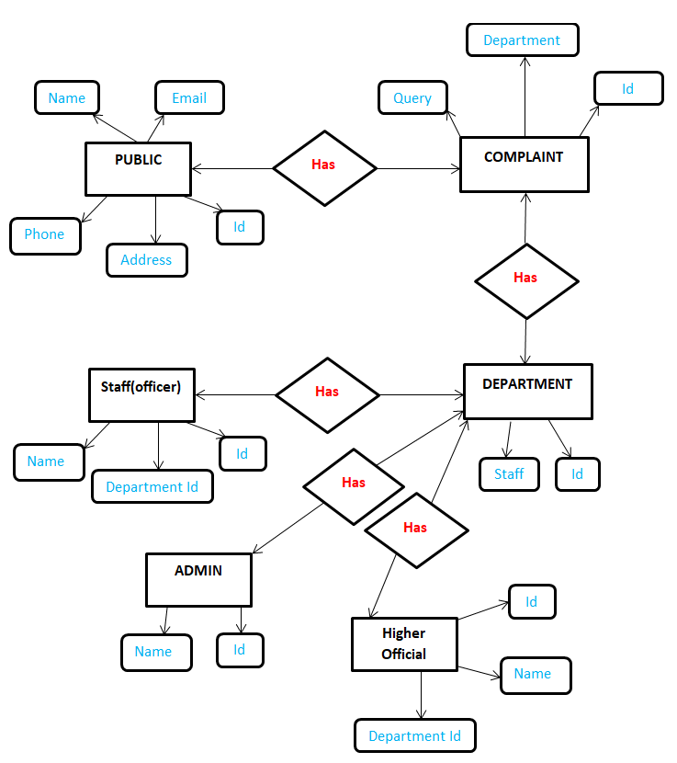***ER Diagram (*Entity Relationship Diagram*)*** was constructed.   
       The Entity Relational Model (ER Model) serves as a framework for identifying and representing entities within a database, elucidating how these entities interrelate. This model elucidates the intricate relationships among various entities within the database, providing a comprehensive overview of their connections. ER diagrams are instrumental in visually illustrating the associations between real-world entities, such as individuals, vehicles, or organizations, and delineating the relationships between them. The figure below depicts the various entities that interact with the portal. **Fig. 1 – ER cat Fig. 1 – ER Diagram**
    2. ***Workflow Diagram*** was constructed.   
       The workflow of a public grievance redressal system typically begins with users submitting their grievances through an online platform or designated channels. These complaints are then routed to the relevant department or authority responsible for addressing them. Upon receipt, the department assesses the nature and severity of the grievance and assigns it to the appropriate personnel for resolution. Throughout the process, regular updates are provided to the complainant regarding the status of their grievance. Once resolved, feedback may be solicited from the user to gauge their satisfaction with the resolution process. Continuous monitoring and analysis of grievances help in identifying systemic issues and improving the efficiency of the redressal system over time.

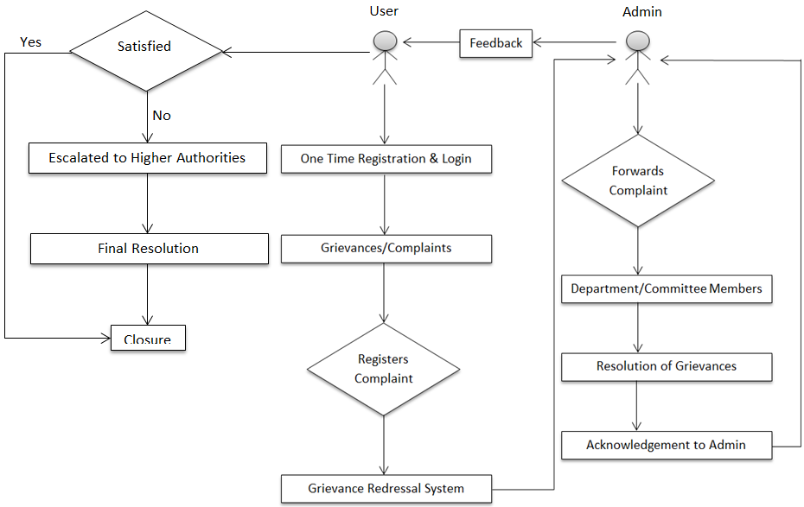

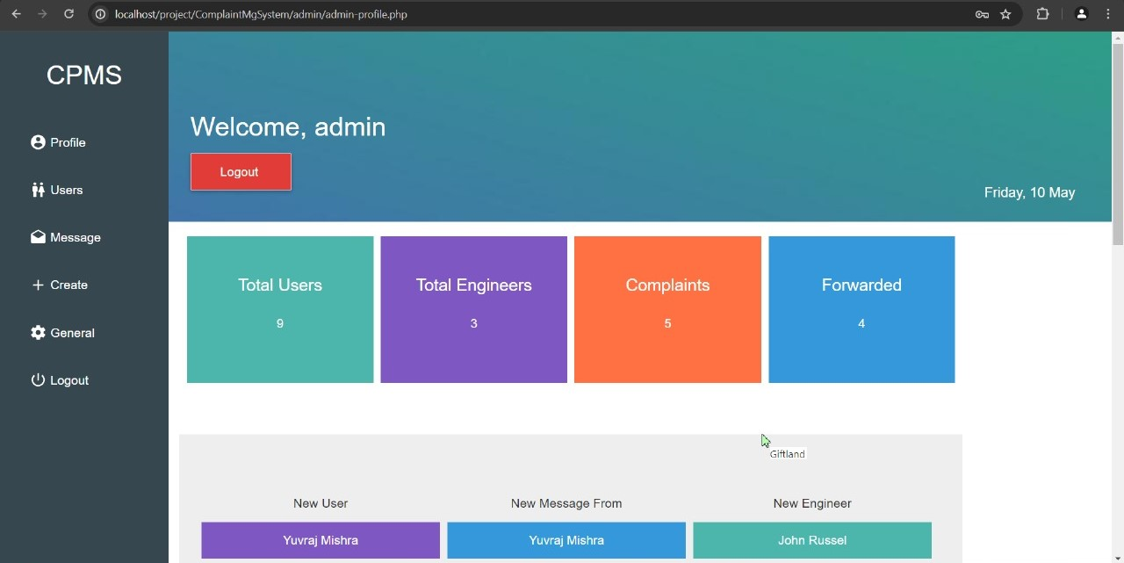

**Fig. 2 - Workflow Diagram**

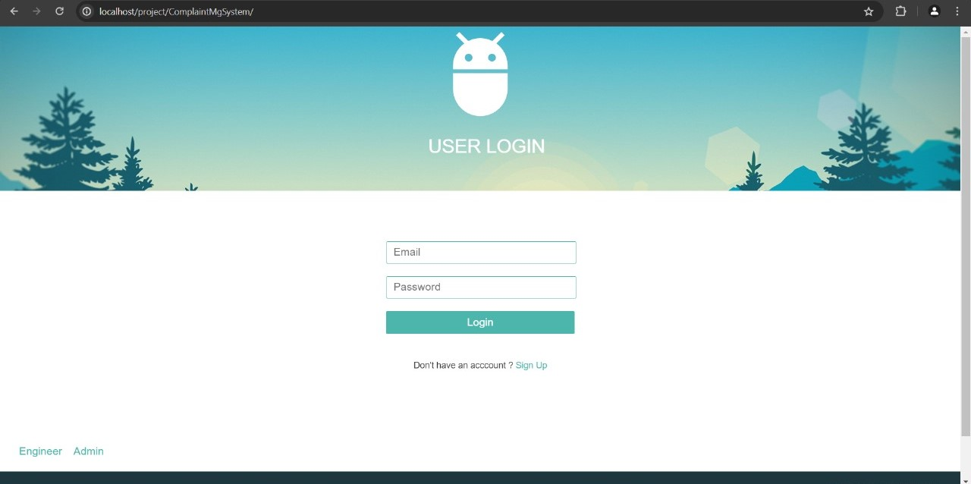***6.2 Main Interface***: The landing page serves as a central hub for users, administrators, and department members to access the portal's features. It provides a seamless entry point into the portal's ecosystem, allowing users to submit complaints, manage administrative tasks, and address departmental responsibilities. The primary interface illustrates the portal's diverse functionalities.

**Fig. 3 - Main Interface**

***6.3* *Login/Sign-up:*** To utilize the resources and features of the Grievance Redressal System, every user must register on the website. This enables users to access to a dynamic dashboard tailored to each individual and allows for efficient tracking and management of grievances, enhancing satisfaction and efficiency. The system's user-centric experience enhances overall satisfaction and efficiency in addressing grievances.

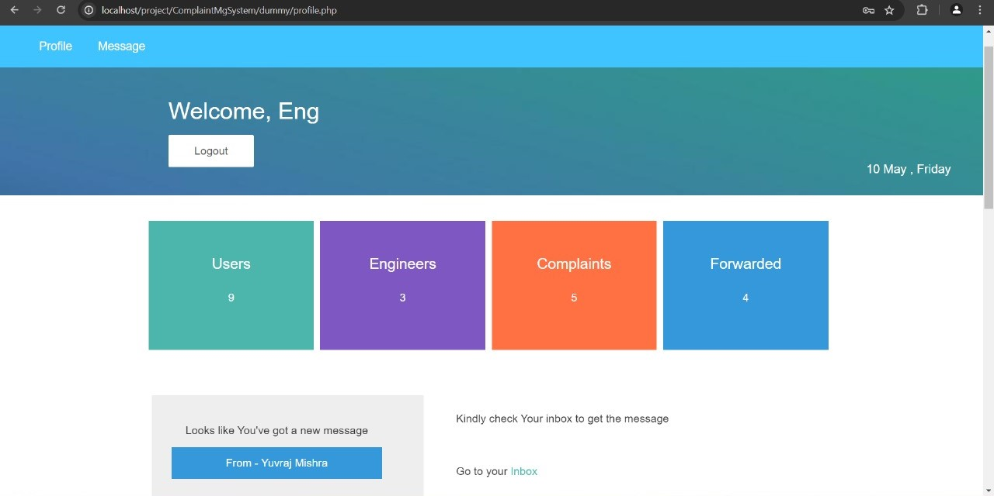

**Fig .4 – Department/Staff Member page**

***6.4 Our Services:*** These services include a user-friendly platform for submitting grievances online, streamlined complaint tracking to monitor the progress of submitted issues, and timely updates on the status of complaints. Users also have access to personalized accounts enabling them to receive tailored reports and utilize dynamic dashboards for enhanced engagement. Furthermore, the system facilitates seamless communication between users, administrators, and department members, ensuring swift resolution of grievances. Additionally, the system offers feedback mechanisms to gather user input, aiding in continuous improvement and optimization of services. Overall, the Public Grievance Redressal System provides comprehensive support to address public concerns effectively and foster greater transparency and accountability within the administration.

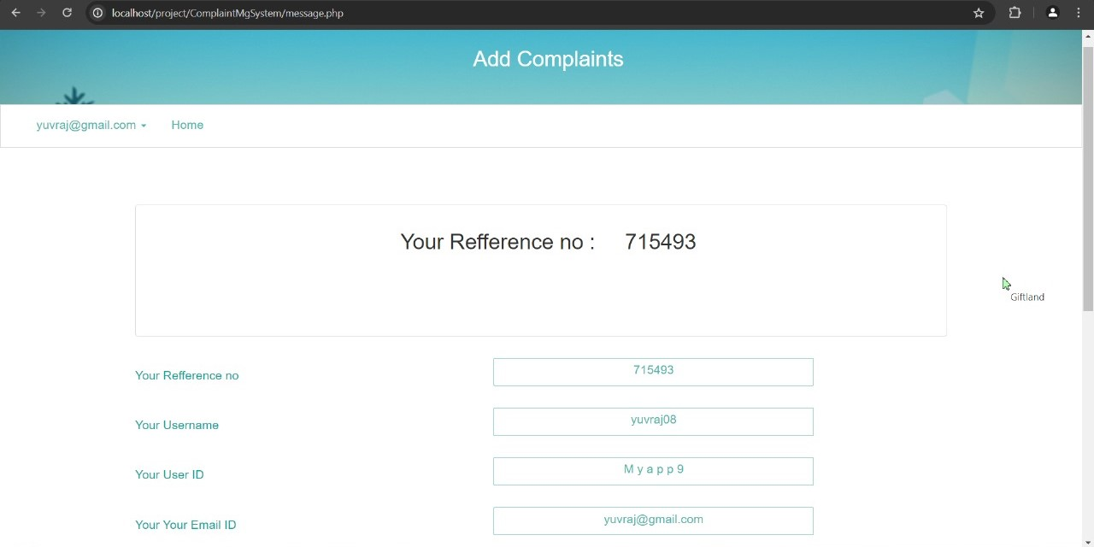  **Fig. 5 – Admin Page**

**Fig. 6 – Add Complaint Page**

1. RESULT

A number of important goals are accomplished by the Public Grievance Redressal System that are meant to improve accountability, efficiency, and transparency in handling public complaints. For those looking for a resolution, the system guarantees accessibility and usability by offering a user-friendly online grievance submission platform. By means of expedited complaint tracking and consistent grievance status updates, the system cultivates user trust and confidence by showcasing a dedication to prompt resolution. Personalised accounts also give customers access to dynamic dashboards and customised reports, giving them more visibility and control over their complaints.

Furthermore, the system facilitates efficient communication among users, administrators, and department members, enhancing problem-solving and collaboration. It continuously analyzes grievances and seeks user input, promoting transparency, accountability, and citizen engagement, thus enhancing the efficiency and effectiveness of grievance redressal processes.

1. DISCUSSION

In discussion, several key points come to the forefront. Accessibility is a crucial aspect of a system, ensuring users can easily submit complaints and access its functionalities. The user interface plays a vital role in facilitating this accessibility, with its design and usability ensuring a seamless experience. The system's effectiveness is based on its complaint management process, which categorizes, tracks, and resolves grievances. Transparency is essential, with stakeholders expecting clear communication. Accountability mechanisms are crucial for holding responsible parties accountable. Efficiency is also important, with the system's ability to handle complaints promptly. Stakeholder engagement is vital, with citizens, administrators, and department members all involved. Feedback mechanisms drive continuous improvement. The technological infrastructure supporting the system must be robust, incorporating security measures and efficient data management practices. Continuous evaluation and enhancement strategies are necessary to ensure the system remains responsive to evolving user needs and challenges.

1. LIMITATIONS

The study on the Grievance Redressal System reveals several limitations, including insufficient user awareness, administrative inefficiencies, and resource constraints. These issues lead to underutilization, unresolved grievances, and decreased user satisfaction. To improve the system's effectiveness, it is suggested to implement comprehensive reforms, such as enhancing user outreach, streamlining administrative processes, strengthening transparency measures, and ensuring adequate resource allocation. This will help promote fairness, accountability, and justice within society.

1. CONCLUSION

The Grievance Redressal System is a PHP-based system designed to address societal grievances with accessibility, transparency, and efficiency. It integrates user-centric design principles and innovative technological solutions, such as MySQL database management and form validation. The system ensures data integrity and confidentiality, facilitating seamless interaction between users and administrators. Continuous monitoring and stakeholder engagement are crucial for long-term effectiveness. The system's emphasis on user satisfaction and procedural fairness builds trust and confidence in the grievance redressal process. This project demonstrates the potential of PHP-based systems in promoting transparency, accountability, and responsive governance.

1. REFERENCES
2. Rana, Nripendra P., et al. "Adoption of online public grievance redressal system in India: Toward developing a unified view." *Computers in Human Behavior* 59 (2016): 265-282.
3. Rana, Nripendra, Michael Williams, and Yogesh Dwivedi. "Examining factors affecting adoption of online public grievance redressal system: A case of India." (2013).
4. Chander, Subhash, and Ashwani Kush. "Assessing grievances redressing mechanism in India." *International Journal of Computer Applications* 52.5 (2012).
5. Rana, Nripendra P., Yogesh K. Dwivedi, and Michael D. Williams. "Examining the factors affecting intention to use of, and user satisfaction with online public grievance redressal system (OPGRS) in India." *Grand Successes and Failures in IT. Public and Private Sectors: IFIP WG 8.6 International Working Conference on Transfer and Diffusion of IT, TDIT 2013, Bangalore, India, June 27-29, 2013. Proceedings*. Springer Berlin Heidelberg, 2013.
6. Chowdhury, Md Shahidul Islam. "Strengthening Grievance Redress System: A Case of Narsingdi District Administration." *angladesh ournal of ublic dministration* 31.1 (2023): 23-46.
7. Shettigar, Rakshitha, et al. "Blockchain-Based Grievance Management System." *Evolution in Computational Intelligence: Frontiers in Intelligent Computing: Theory and Applications (FICTA 2020), Volume 1*. Springer Singapore, 2021.
8. Prajapat, Shaligram, Vaibhav Sabharwal, and Varun Wadhwani. "A prototype for grievance redressal system." *Proceedings of International Conference on Recent Advancement on Computer and Communication: ICRAC 2017*. Springer Singapore, 2018.
9. Shahi, Abhinav. "Grievance Redressal in India during Pandemic and the Way Forward." *ASCI Journal of Management* 51.1 (2022).
10. Aravindhan, K., et al. "Web Portal for Effective Student Grievance Support System." *2020 6th International Conference on Advanced Computing and Communication Systems (ICACCS)*. IEEE, 2020.
11. Rana, Nripendra P., et al. "An extended DeLone and McLean's information system model for examining success of online public grievance redressal system in Indian context." *International Journal of Indian Culture and Business Management* 10.3 (2015): 267-290.
12. Kumar, Anil, et al. "Does e‐service quality of online grievance redress portals lead to satisfaction? An outlook from the perspectives of I ndian youth." *Journal of Public Affairs* 23.1 (2023): e2822.

|  |
| --- |
|  |
|  |
| APA |  |